

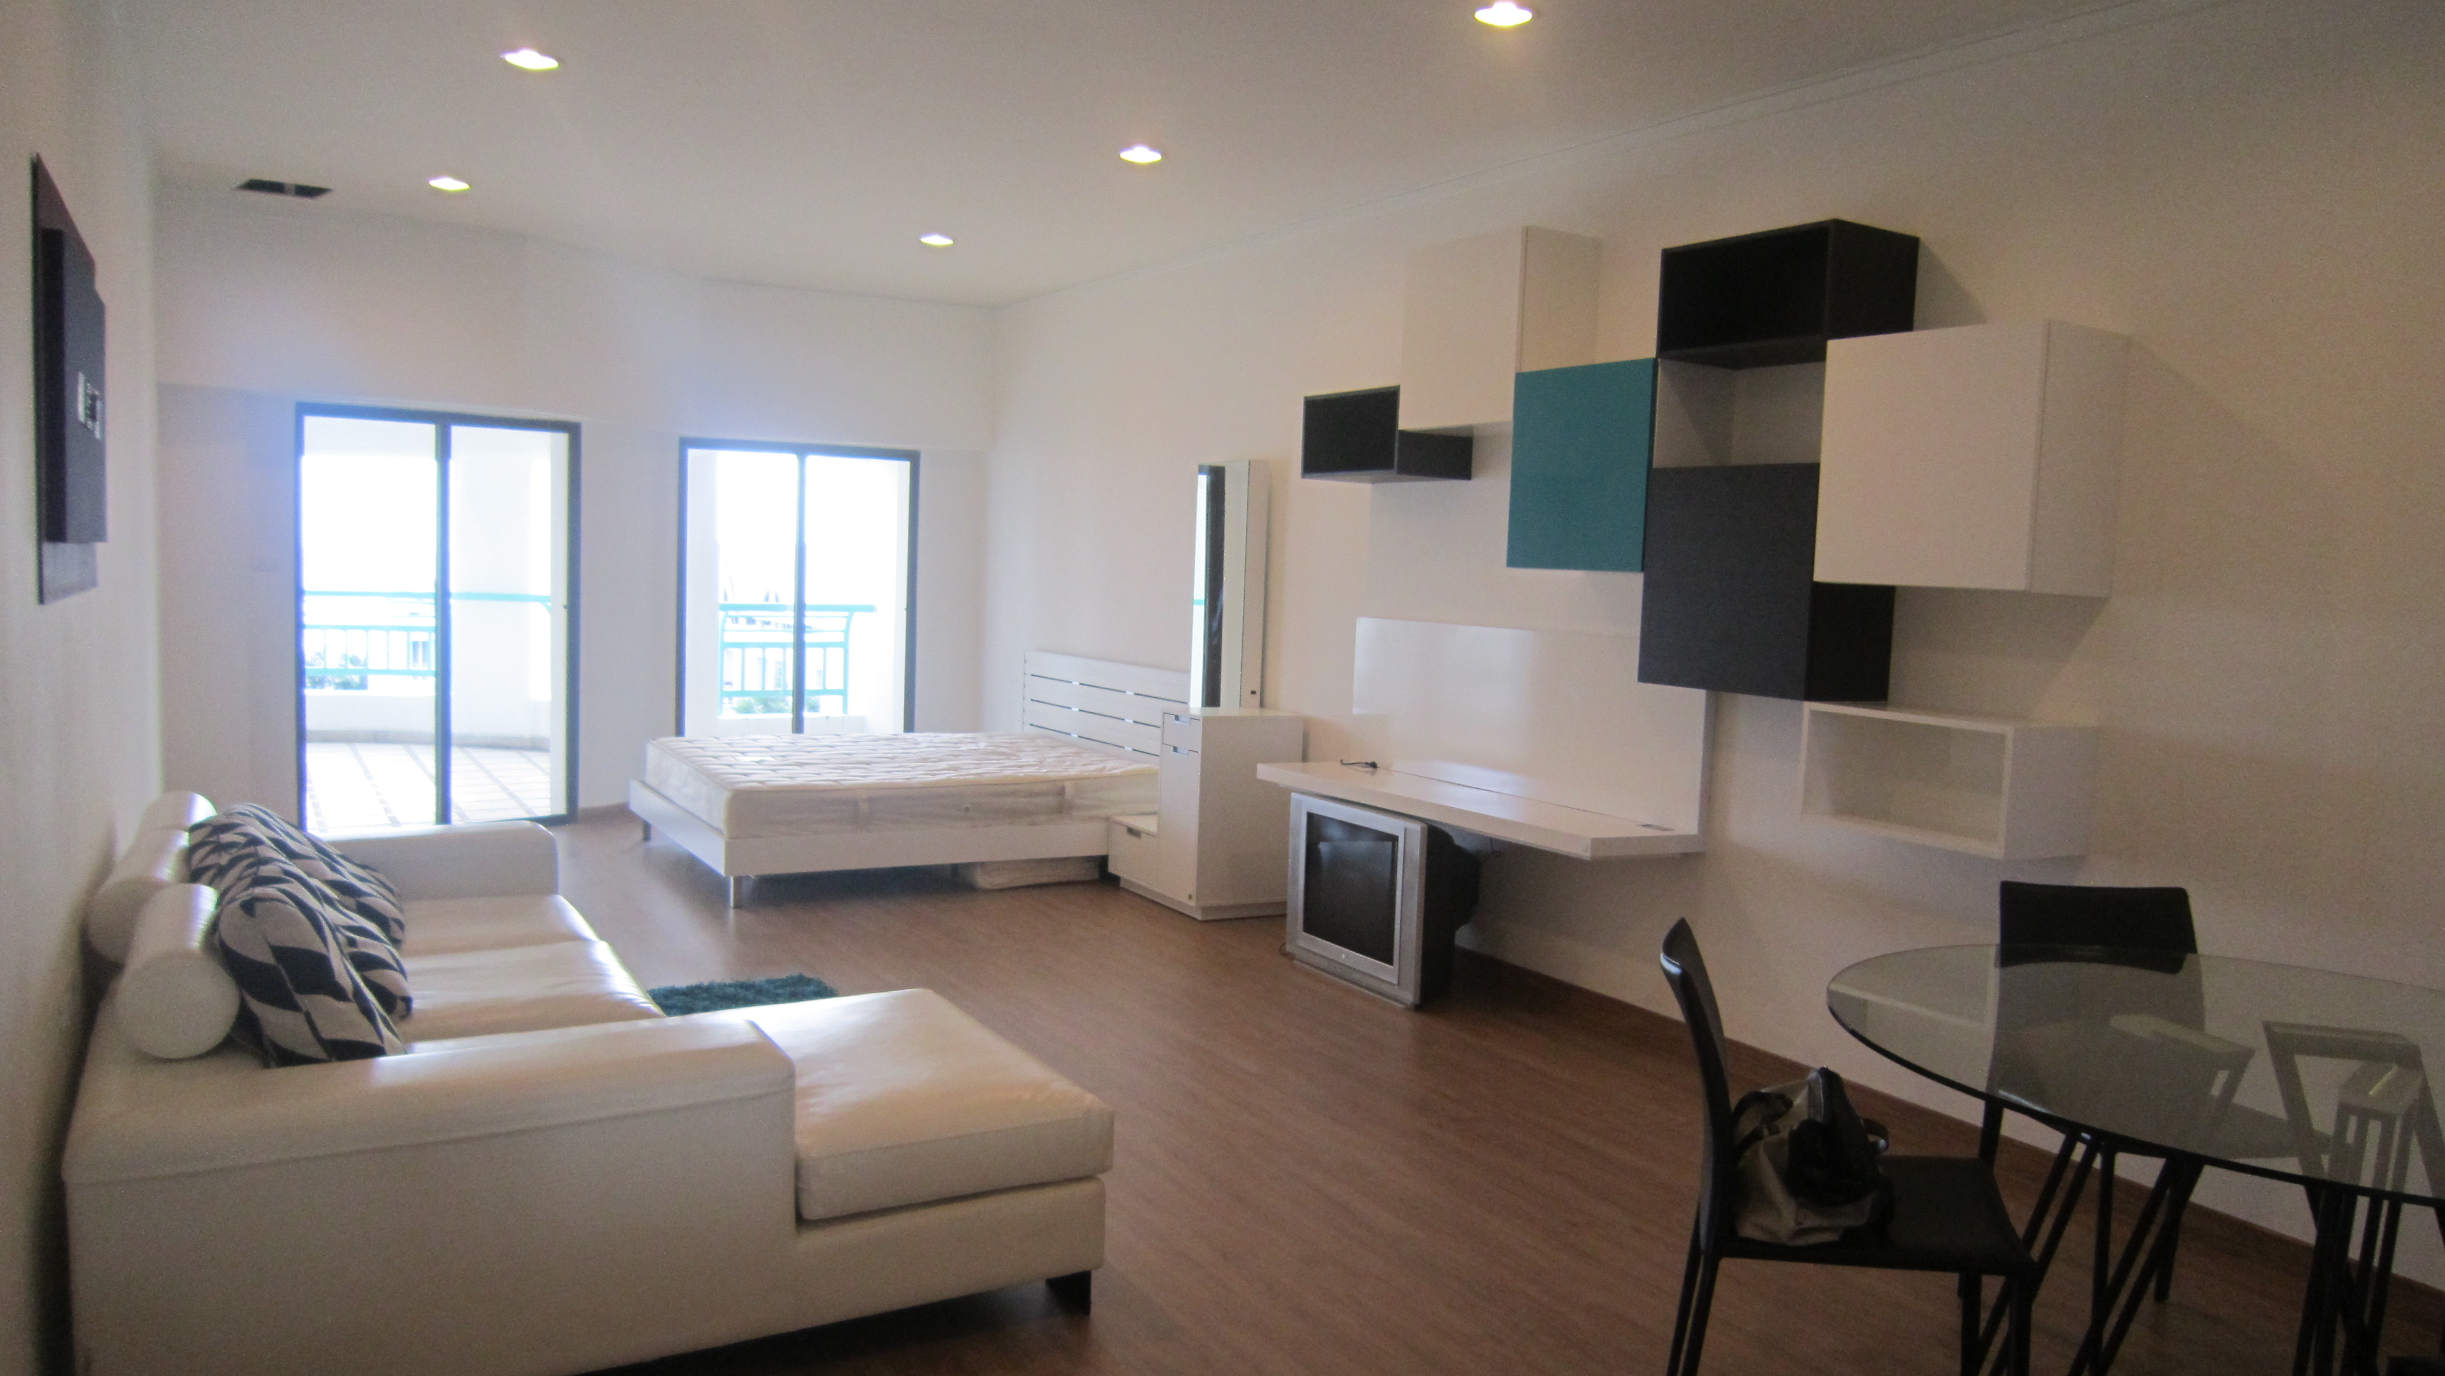

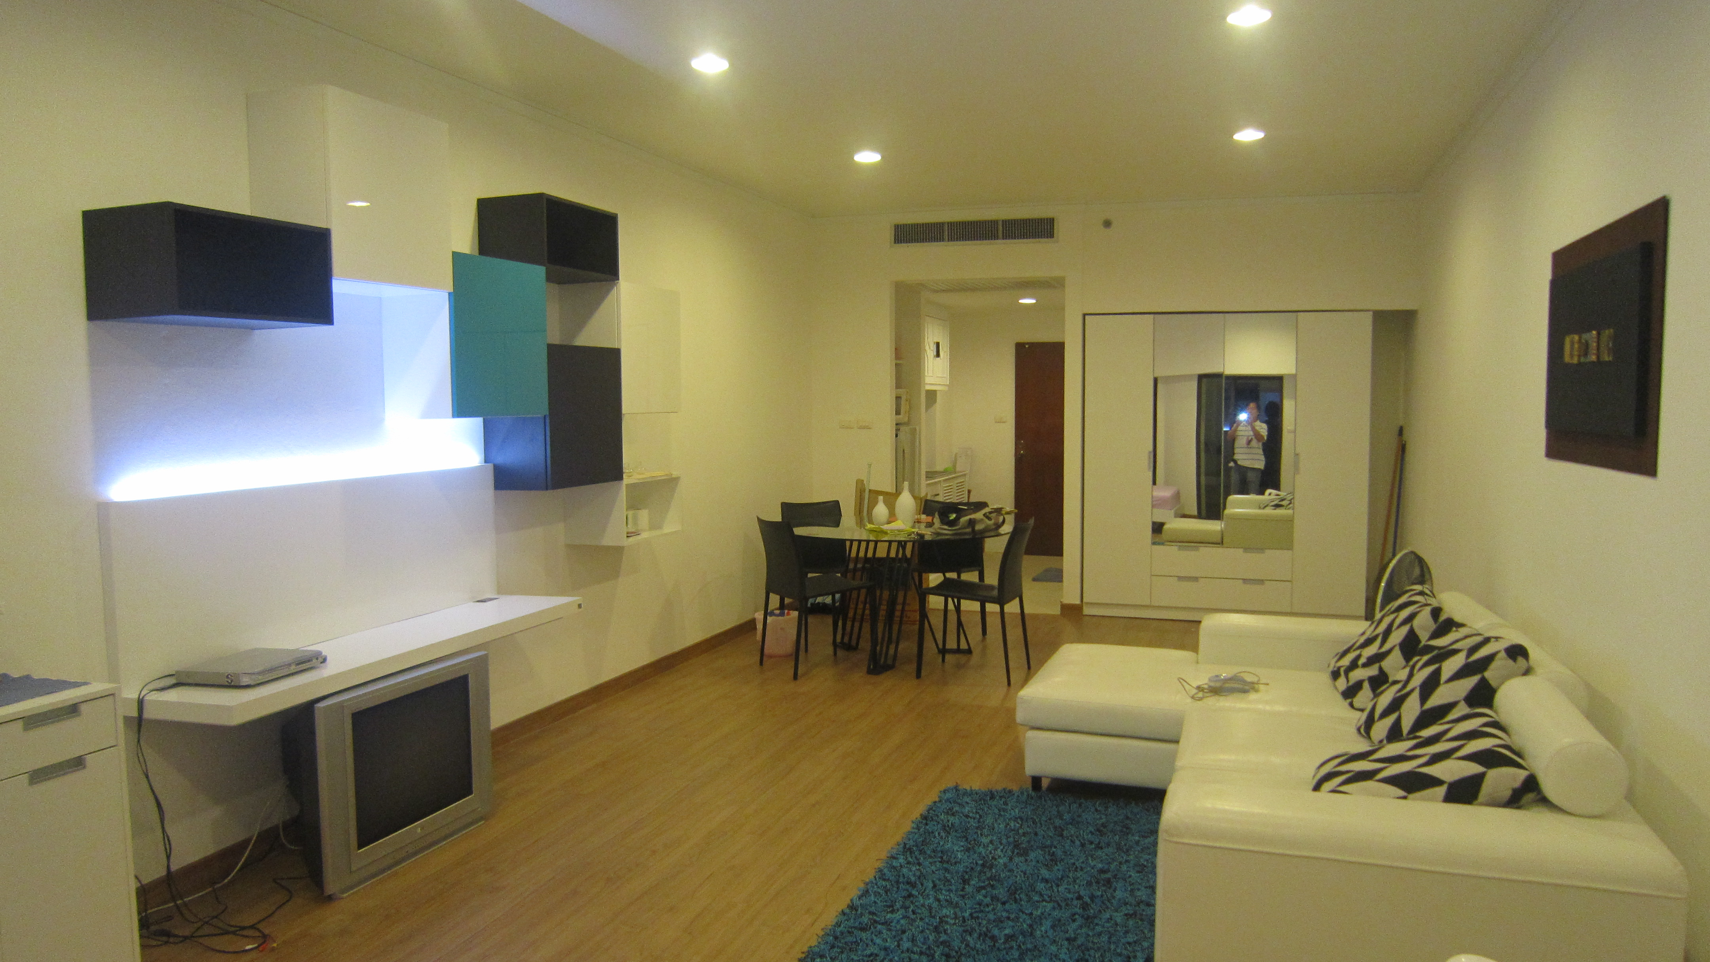

Call : 089-815-0223

**Condominium 70 sqm. Level 4, Studio.**

**Jomtien Beach Front. Na Jomtien Soi 19.**

**New Decorated.  
Swimming Pool and Sea View.**

**Include : Furniture,**

**Air-condition, TV, Refrigerator.**

**17,000 Baht/Month**

